1. Please see the below picture. Implement to html and give an alert message in every div when user clicked the div, the message is div’s name.

**Example** : when user click the Div 2 then alert “**DIV 2**” is appear

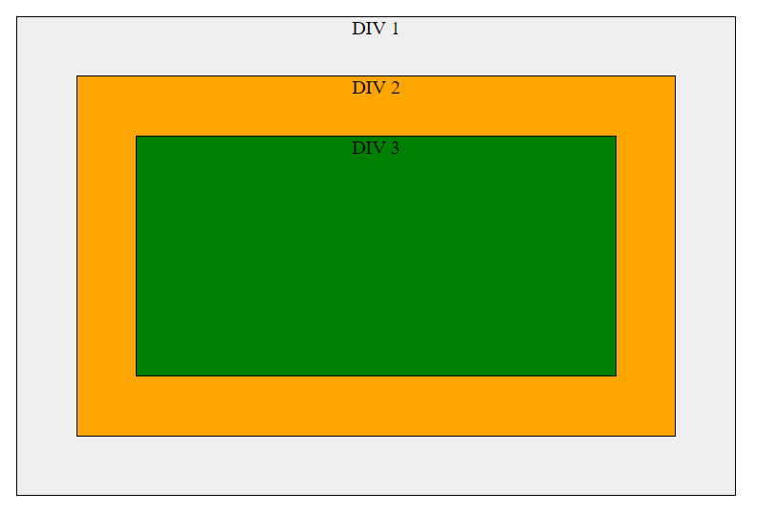

1. Given a list of cloth N engineers have, implement the following method in javascript which return whether it's possible to have a combination where no one wear the same cloth.

**Example**:

clothes[0] = ["JakartaJS"]

clothes[1] = ["AWSome Day", "Elixir"]

clothes[2] = ["GoJakarta", "Elixir"]

**Output**: true. Example of possible combination: ["JakartaJS", "AWSome Day", "Elixir", "GoJakarta"]

clothes[0] = ["JakartaJS", "Elixir"]

clothes[1] = ["Elixir"]

clothes[2] = ["JakartaJS ","Elixir"]

**Output**: false.

1. Please see the below picture. Implement to a project, with asset already given. Feel free to use javascript framework which you prefer (ReactJS, Angular, Vue, Jquery, etc). For the data, please fetching data using ajax, axios or another library in javascript.

* Page 1

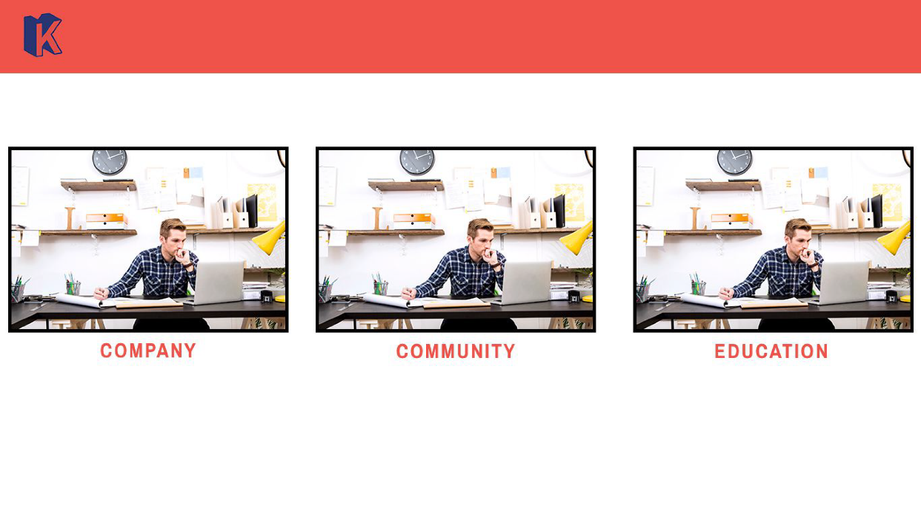

* Page 2



* Page 3

